**Research Project**

**Examining the Relation Between Temperature and Bird Occurrences in Southland, New Zealand**

**SCI ENVI 303**

**Shaivan Bhagat**

**May 11, 2023**

**Examining the Relation Between Temperature and Bird Occurrences in Southland, New Zealand**

**Introduction**

Changes in the environment affect animal populations and their habitat. Over the past few years there has been an increase in the average global temperature due to climate change. Cohen et al. (2021) believe that such changes in temperature will disrupt bird occurrence and abundance patterns at both local and global scales. The aim of this paper is to investigate the relationship between temperature and occurrences of birds from three different families in Southland, New Zealand. The bird families in consideration are *Phalacrocoracidae*, *Petroicidae* and *Rallidae*. It is hypothesized that there would be a negative relationship between the observed temperature and occurrences of birds of these families in Southland. Southland is chosen as the target region in New Zealand due to its species diversity and richness. This allows a greater sample size which represents the actual populations of the region more accurately.

**Methods.**

To test the given hypothesis, data regarding bird occurrences and weather in Southland was used which was provided by University College Roosevelt’s data center project on GitHub. The data spans over 10 years from 2010-2020 and contains bird observations, geographical location, size and weight of specific bird species along with weather data of local regions in South Island, New Zealand. All of this data combined had about 20,000 entries making the nature of the study both extensive and reliable.

The statistical software R-studio (Version 4.2.2) was extensively used to analyze and interpret the datasets. Using R-studio, the datasets were combined using similar methods as shown on the UCR data center website by means of filtering for relevant information. The data was filtered for the families of *Phalacrocoracidae*, *Petroicidae* and *Rallidae* and for their occurrences in Southland along with their geographical location. These families were selected since they have the highest number of observations in the region of Southland. Data regarding the climate was obtained from a different file on UCR’s data center project and was filtered for temperature over the same time period (2010-2020) to attain information on local weather conditions. After conducting our analyses, the final data will be plotted as a line chart scatterplot and as a geospatial map to see the influence of temperature on the occurrences of birds. These methods however only give a visual representation. To obtain a quantitative relation, a linear model will be used specifically to check for the p-value to see if there is any statistical significance between the temperature and occurrences of our target bird families.

**Results**

Figure 1 represents the abundance of various families of birds in Southland. The highest observations were for *Petroicidae* (n=5044), *Phalacrocoracidae* (n=2745), and *Rallidae* (n=1719). Figure 2 depicts the distribution of these 3 families from 2010-2020.

Figure 1: Histogram plot representing the abundance of various bird families in the region of Southland, NZ.

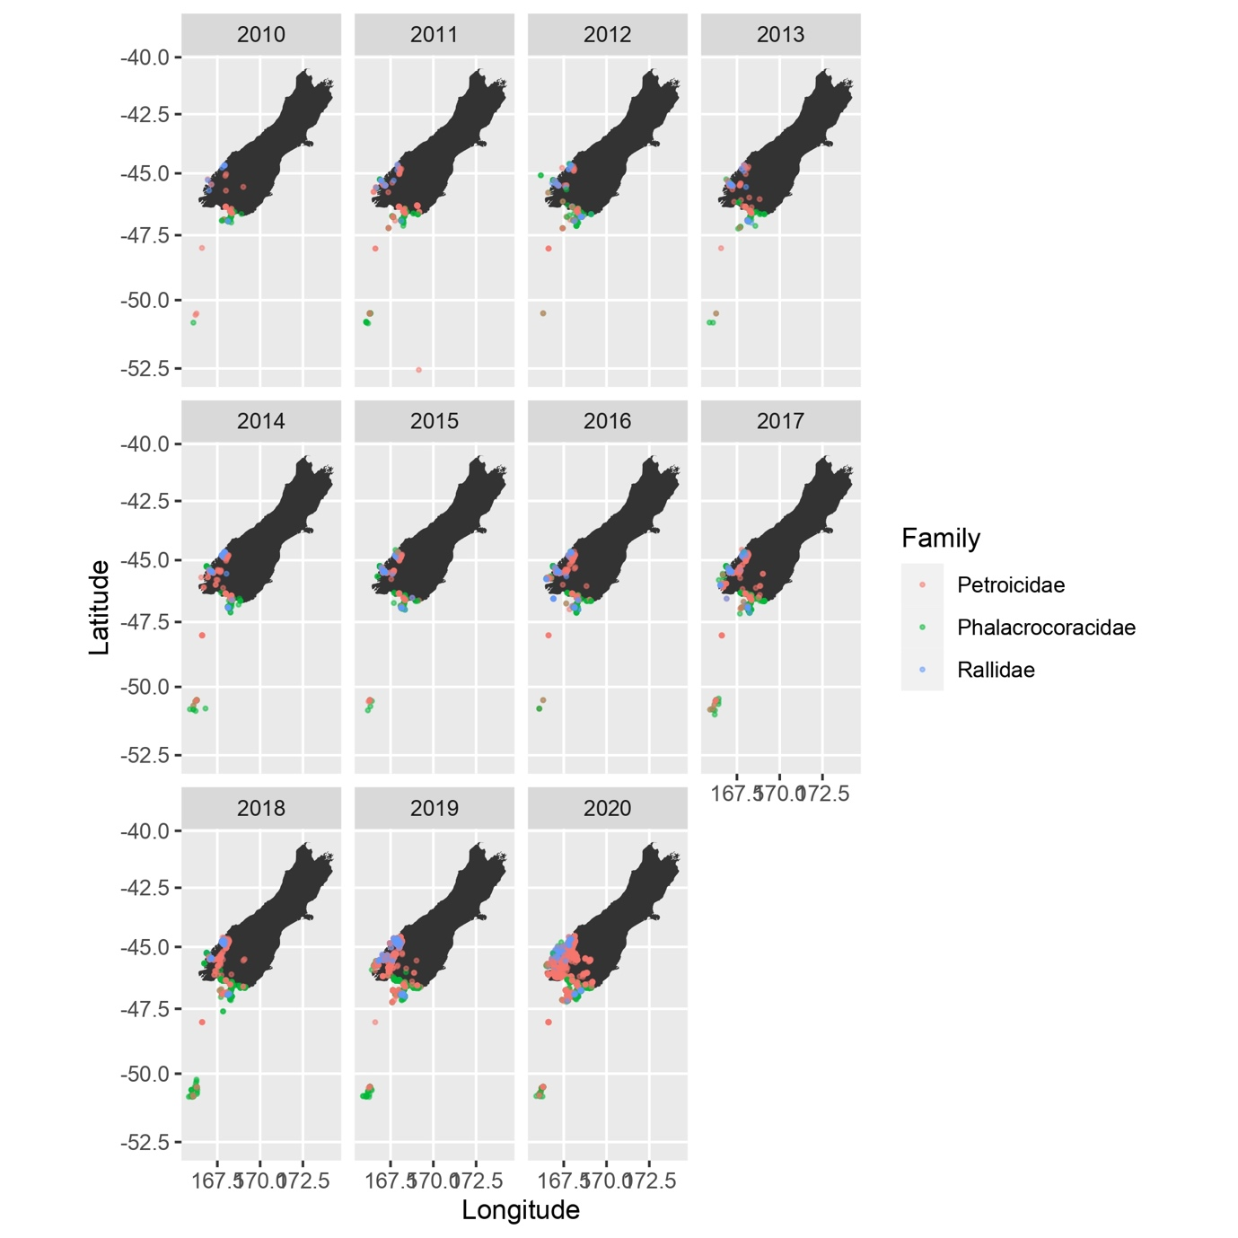Figure 2: A geospatial plot of the occurrences of birds in Southland, NZ for 3 different bird families (*Phalacrocoracidae*, *Petroicidae*, *Rallidae)*

From Figure 3, we can infer that as the temperature increases, the number of birds observed for the family *Petroicidae* increases as well. A peak in the number of occurrences is seen at 12˚ C which decreases and then increases again almost linearly until 16˚C. However, through quantitative analysis, it was seen that the relation is not statistically significant (p-value = 0.479).

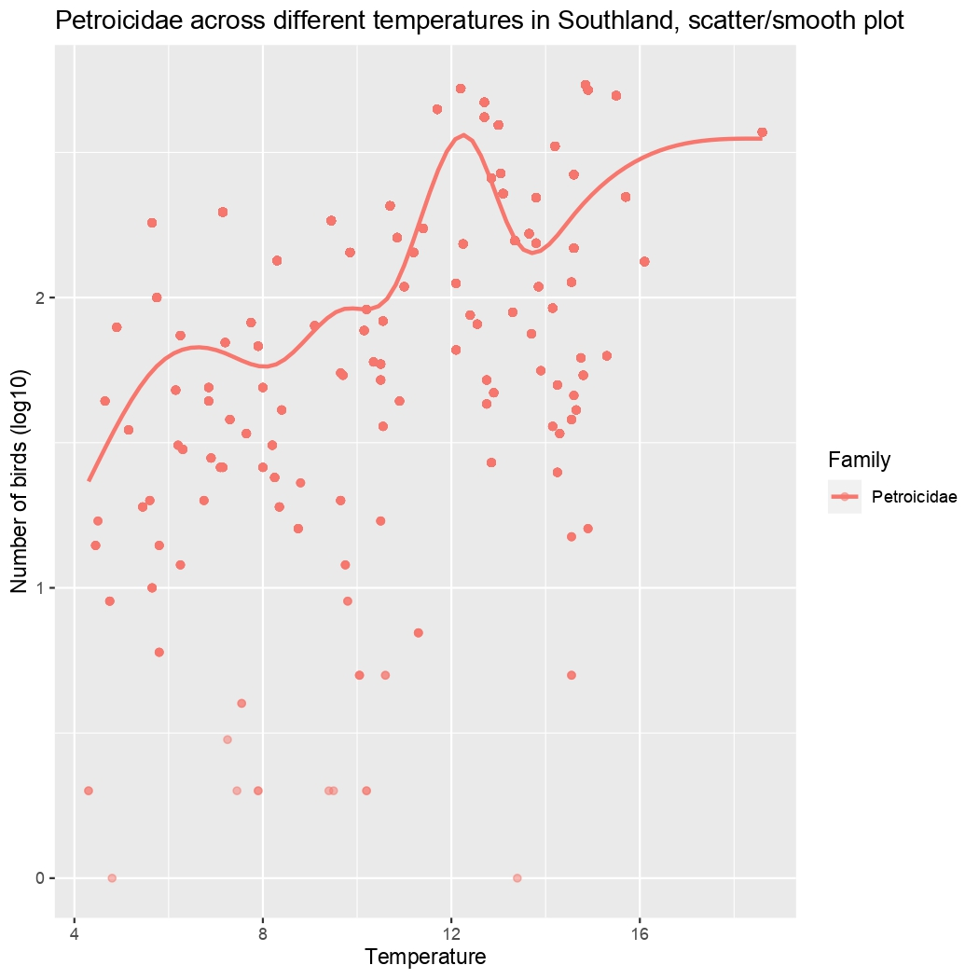

Figure 3: Line chart scatter plot representing the relation between temperature (˚C) and bird occurrences (in log10) for the family *Petroicidae* in Southland

From Figure 4, we can infer that as the temperature increases, the number of birds observed for the family *Phalacrocoracidae* increases as well. A peak in the number of occurrences is seen at 12˚C which decreases and then increases again until 16˚C almost linearly. Through quantitative analysis, it was seen that this relation is statistically significant (p-value = 0.0168).

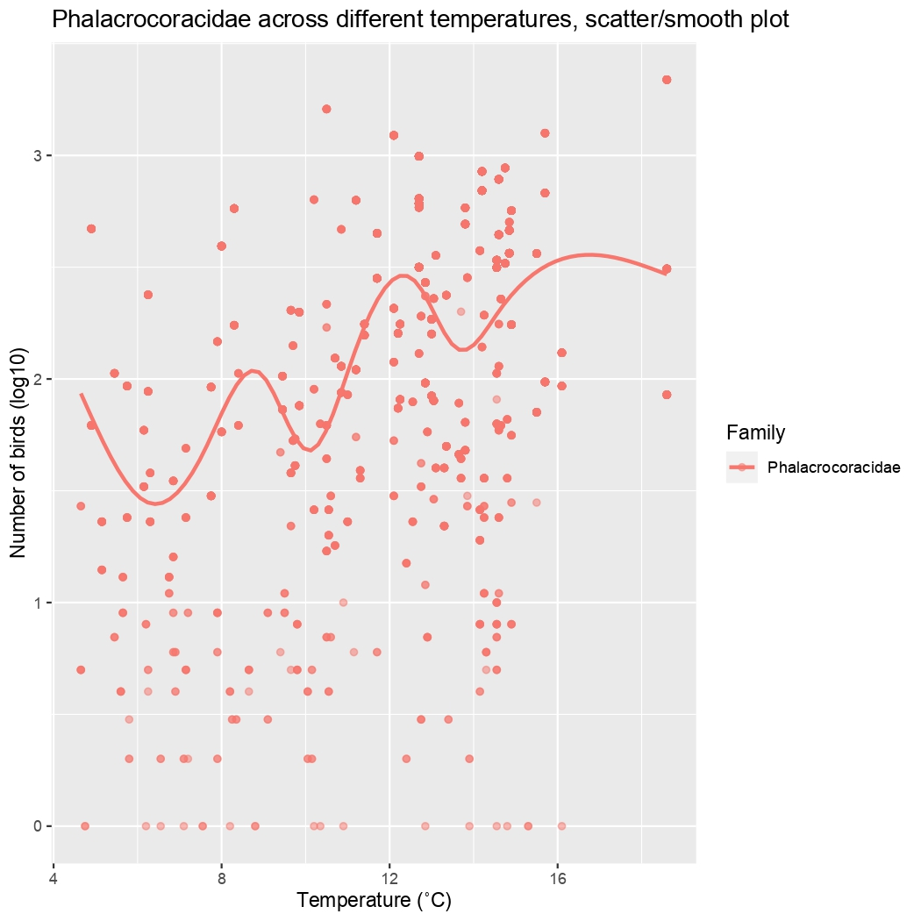

Figure 4: Line chart scatter plot representing the relation between temperature (˚C) and bird occurrences (in log10) for the family *Phalacrocoracidae* in Southland

From Figure 5, we can see that as the temperature increases, the number of birds observed for the family *Rallidae* increases. A peak in the number of occurrences is seen just after 12˚ C which then decreases. Through quantitative analysis, it was seen that this relation is highly statistically significant (p-value = 0.00930).

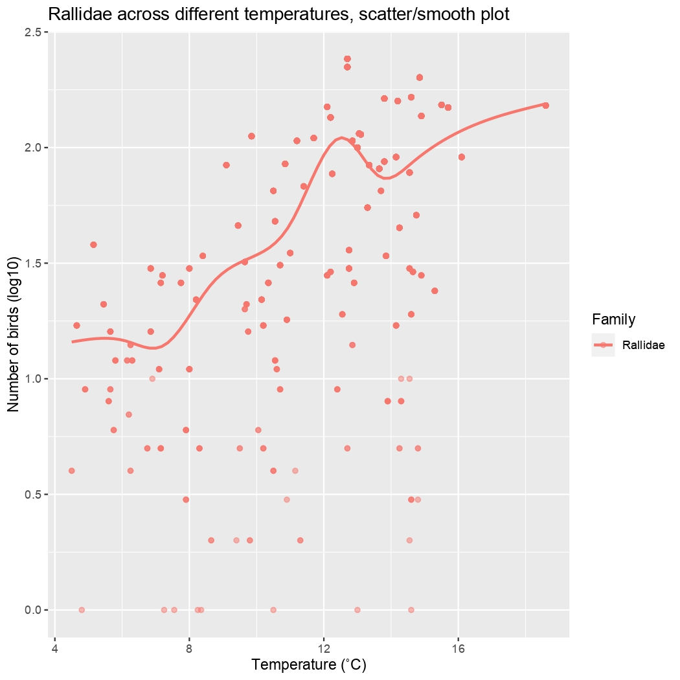

Figure 5: Line chart scatter plot representing the relation between temperature (˚C) and bird occurrences (in log10) for the family *Rallidae* in Southland

**Conclusion**

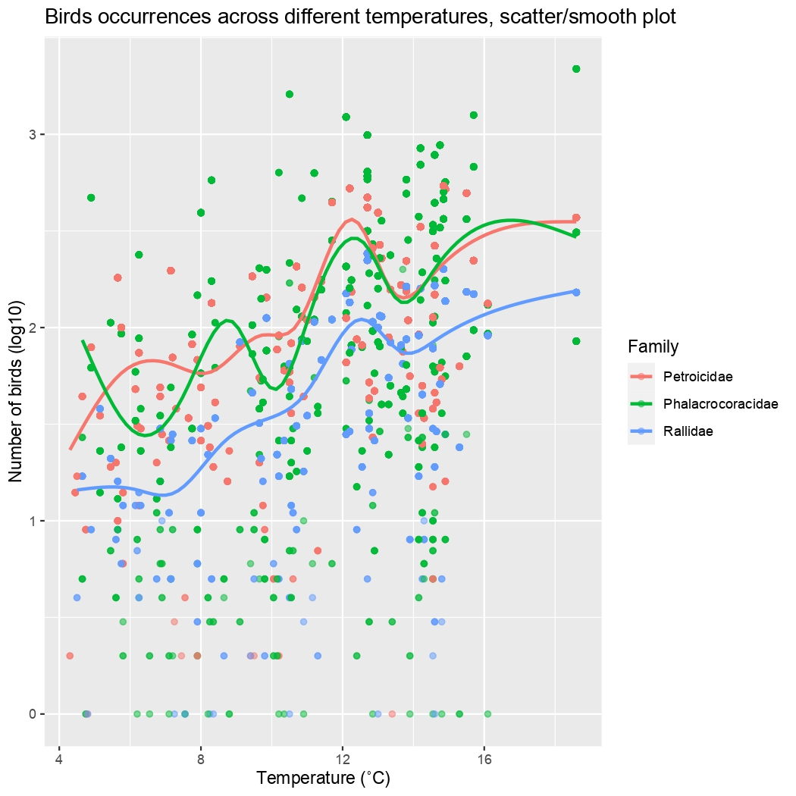Figure 6: Line chart scatter plot representing the relation between temperature (˚C) and bird occurrences (in log10) for the families *Petroicidae*, *Phalacrocoracidae* and *Rallidae* in Southland

From figure 6, we can conclude that an increase in the number of bird occurrences was observed for all three families in the region of Southland, NZ with a peak distribution around 12 ˚C. This could imply that 12˚C is the optimal temperature for these birds in Southland. Thus, the original hypothesis is proved wrong and there is not a negative relationship between rising temperatures and bird occurrences, instead it is positive. However, this could also be attributed to a greater number of observations recorded at higher temperatures in the region of Southland. Further analysis into the relation of occurrences and temperature of the same bird families in different regions of New Zealand would be required.

**Appendix**

UCR Data Center Project

(<https://github.com/ucrdatacenter/projects/tree/main/SCIENVI303/2023h1/ass2>).

**References**

Cohen, J., Fink, D., & Zuckerberg, B. (2021). Extreme winter weather disrupts bird occurrence and abundance patterns at geographic scales. *Ecography*, *44*(8), 1143–1155. https://doi.org/10.1111/ecog.05495

*Projects/SCIENVI303/2023h1 at main · ucrdatacenter/projects*. (2022). GitHub. Retrieved May 11, 2023, from <https://github.com/ucrdatacenter/projects>